
LPU CA 02 - 04 (A)

Directions of Test
 | Test Name |  |  |  | LPU CA 02 - 04 (A) |  |  |  | Total Questions |  |  |  |  |  | 30 |  |  | Total Time |  |  |  |  | 50 Mins
 | Section Name |  |  |  | No. of Questions |  | Time limit |  |  |  |  | Marks per Question |  |  |  |  |  |  |  | Negative Marking
 | Section 1 |  |  |  | 6 |  |  |  | 0:10(h:m) |  |  |  | 1 |  |  |  |  |  |  |  | 1/4
 | Section 2 |  |  |  | 6 |  |  |  | 0:10(h:m) |  |  |  | 1 |  |  |  |  |  |  |  | 1/4
 | Section 3 |  |  |  | 6 |  |  |  | 0:10(h:m) |  |  |  | 1 |  |  |  |  |  |  |  | 1/4
 | Section 4 |  |  |  | 6 |  |  |  | 0:10(h:m) |  |  |  | 1 |  |  |  |  |  |  |  | 1/4
 | Section 5 |  |  |  | 6 |  |  |  | 0:10(h:m) |  |  |  | 1 |  |  |  |  |  |  |  | 1/4

Section : Section 1

DIRECTIONS for the question: Solve the following question and mark the best possible option.

Question No. : 1

One year ago, the ratio of Honey and Piyush ages was 2: 3 respectively. After five years from now, this ratio becomes 4: 5. How old is Piyush now?

A) 15 years B) 12 years C) 17 years D) 10 years

DIRECTIONS for the question: Solve the following question and mark the best possible option.

Question No. : 2

Ram’s age was square of a number last year and it will be cube of a number next year. How long must he wait before his age is again the cube of a number?

A) 39 years B) 10 years C) 38 years D) 64 years

DIRECTIONS for the question: Solve the following question and mark the best possible option.

Question No. : 3

The ages of Sumina and Suhana are in the ratio of 7 : 3. After 6 years the ratio of their ages will be 5 : 3. What is the difference in their present ages?

A) 6 years B) 8 years C) 10 years D) 12 years

DIRECTIONS for the question: Solve the following question and mark the best possible option.

Question No. : 4

Father's age is three years more than three times the son's age. After three years, father's age will be ten years more than twice the son's age. What is the father's present age?

A) 36 B) 35 C) 30 D) 33

LPU CA 02 - 04 (A)

DIRECTIONS for the question: Solve the following question and mark the best possible option.

Question No. : 5

If twice the age of daughter is added to three times the age of mother, the sum is 120 and if twice the mother's age is added to three times the daughter's age, then the sum is 90. The age of mother is

A) 30 years B) 36 years C) 41 years D) 42 years

DIRECTIONS for the question: Solve the following question and mark the best possible option.

Question No. : 6

12 years old Manick is three times as old as his brother Rahul. How old will Manick be when he is twice as old as Rahul?

A) 14 years B) 16 years C) 18 years D) 20 years

Section : Section 2

DIRECTIONS for the question: Solve the following question and mark the best possible option.

Question No. : 7

The prices of a scooter and a moped are in the ratio of 9 : 5. If a scooter costs Rs. 4,200 more than a moped, find the price, of the moped.

A) Rs. 5,250 B) Rs. 3,350 C) Rs. 6,500 D) Rs. 5,700

DIRECTIONS for the question: Solve the following question and mark the best possible option.

Question No. : 8

A certain sum of money is divided among A, B and C so that for each rupee A has 20 paise, B has 50 paise and C has 30 paise. If B's share is Rs. 3000, then total sum of money is

A) Rs. 7000 B) Rs. 6000 C) Rs. 5000 D) Rs. 4000

DIRECTIONS for the question: Solve the following question and mark the best possible option.

Question No. : 9

If x =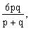then the value of 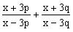is

A)6 B)1 C)5 D)2

DIRECTIONS for the question: Solve the following question and mark the best possible option.

Question No. : 10

In a University, for each Rs. 200 spent by the Cultural Committee, Debating Committee spends Rs. 20 and for every Rs. 400 spent by the Debating Committee, the Student Welfare Committee spends Rs.150. The triple ratio of the money spent by the Cultural Committee to the money spent by the Debating Committee to the money spent by the Student Welfare Committee can be expressed as

A)80:8:3 B)60:8:3 C)40:4:3 D)20:4:3

LPU CA 02 - 04 (A)

DIRECTIONS for the question: Solve the following question and mark the best possible option.

Question No. : 11

Three numbers are in the ratio 1: 2: 3 and their H.C.F is 12. The numbers are

A) 4, 8, 12 B) 5, 10, 15 C) 10, 20, 30 D) 12, 24, 36

DIRECTIONS for the question: Solve the following question and mark the best possible option.

Question No. : 12

Salaries of Ria and Manish are in the ratio 2: 3. If the salary of each is increased by Rs. 4,000/-, the new ratio becomes 40: 57. What is Manish's salary after increment ?

A) 17,000 B) 20,000 C) 25,500 D) 38,000

Section : Section 3

DIRECTIONS for the question: Solve the following question and mark the best possible option.

Question No. : 13

X and Y put in Rs 3,000 and Rs 4,000 respectively into a business. X reinvests into the business his share of the first year's profit of Rs 2,100 whereas Y does not reinvest. In what ratio should they share the second year's profit?

A) 39:40 B) 3:4 C) 3:7 D) 40:79

DIRECTIONS for the question: Solve the following question and mark the best possible option.

Question No. : 14

Three friends Amal, Suman and Haider invested Rs. 2 lakh, Rs. 3 lakh, and Rs. 5 lakh respectively in a business venture. At the end of two years, there was a profit of Rs. 1 lakh. What would be the share of Haider in the profit (in Rs.)?

A) 60,000 B) 40,000 C) 50,000 D) 70,000

DIRECTIONS for the question: Solve the following question and mark the best possible option.

Question No. : 15

A, B and C enter into the partnership by investing in the ratio 2:3:4. After one year, B invests another Rs 12,000. At the end of two years, profits are in the ratio of 3:5:6. What is the final investment of B?

A) Rs 36000 B) Rs 66000 C) Rs 54000 D) Rs 72000

DIRECTIONS for the question: Solve the following question and mark the best possible option.

Question No. : 16

Three partners invested capital in the ratio 2 : 7 : 9. The time period for which each of them invested was in the ratio of the reciprocals of the amount invested. Find the share of the profit of the partner who brought in the highest capital, if profit is Rs. 1080.

A) Rs. 120 B) Rs. 360 C) Rs. 540 D) Rs. 420

LPU CA 02 - 04 (A)

DIRECTIONS for the question: Solve the following question and mark the best possible option.

Question No. : 17

A, B and C are partners. A receives 5/8 of the profit and B & C share the remaining profit equally. A's income is increased by Rs.

450 when the profit rises from 86% to 90%. Find the capital invested by B and C each.

A) Rs. 3,366 B) Rs. 3,375 C) Rs. 3,475 D) Rs. 3,466

DIRECTIONS for the question: Solve the following question and mark the best possible option.

Question No. : 18

A, B and C enter into a partnership. 'A' contributes Rs. 320 for 4 months, 'B' contributes Rs. 510 for 3 months, and 'C' contributes Rs. 270 for 5 months. If the total profit is Rs. 208, find the profit share of A, B and C.

A) Rs. 64, Rs. 76.5 and Rs. 67.5 B) Rs. 46, Rs. 76.5 and Rs. 67 C) Rs. 40, Rs. 50 and Rs. 65 D) Rs. 62, Rs. 72 and Rs. 82

Section : Section 4

DIRECTIONS for the question: Solve the following question and mark the best possible option.

Question No. : 19

In a 120 litre of solution of Acid and water, acid is 75%. A person takes out 20 litres of this solution and added 16.2 litres of acid and 3.8 litres of water in the remaining solution. What is the percentage of water in the final solution?

A) 22 B) 24 C) 25 D) 28

DIRECTIONS for the question: Solve the following question and mark the best possible option.

Question No. : 20

Tericot is a fabric in which Terilene and cotton fibres are mixed in the ratio 3.9:1.1. The Terilene fibre costs Rs.80 per kg while cotton fibre costs Rs. 150 per kg. By using a total of 1 kg of fibres( mixed in the given ratio), 2.15 m of cloth is manufactured. The other costs of manufacturing 2.15 m of cloth amount to Rs. 76.6. What is the cost per meter of the cloth?

A) Rs. 50 B) Rs. 65 C) Rs. 80 D) Rs. 95

DIRECTIONS for the question: Solve the following question and mark the best possible option.

Question No. : 21

The ratio of milk to water in three containers of equal capacity is 3 :2,7 : 3 and 11:4 respectively. The three containers are mixed together. What is the resultant ratio of milk to water after mixing ?

A) 61:29 B) 21: 9 C) 38 : 8 D) 41 :18

DIRECTIONS for the question: Solve the following question and mark the best possible option.

Question No. : 22

The owner of a milk store finds that, he can sell 980 litres of milk each week at Rs 14/litre and 1220 litres of milk each week at Rs 16/litre. Assuming a linear relationship between selling price and demand, how many litres could he sell weekly at Rs 17/litre?

A) 1210 B) 1340 C) 1460 D) 1580
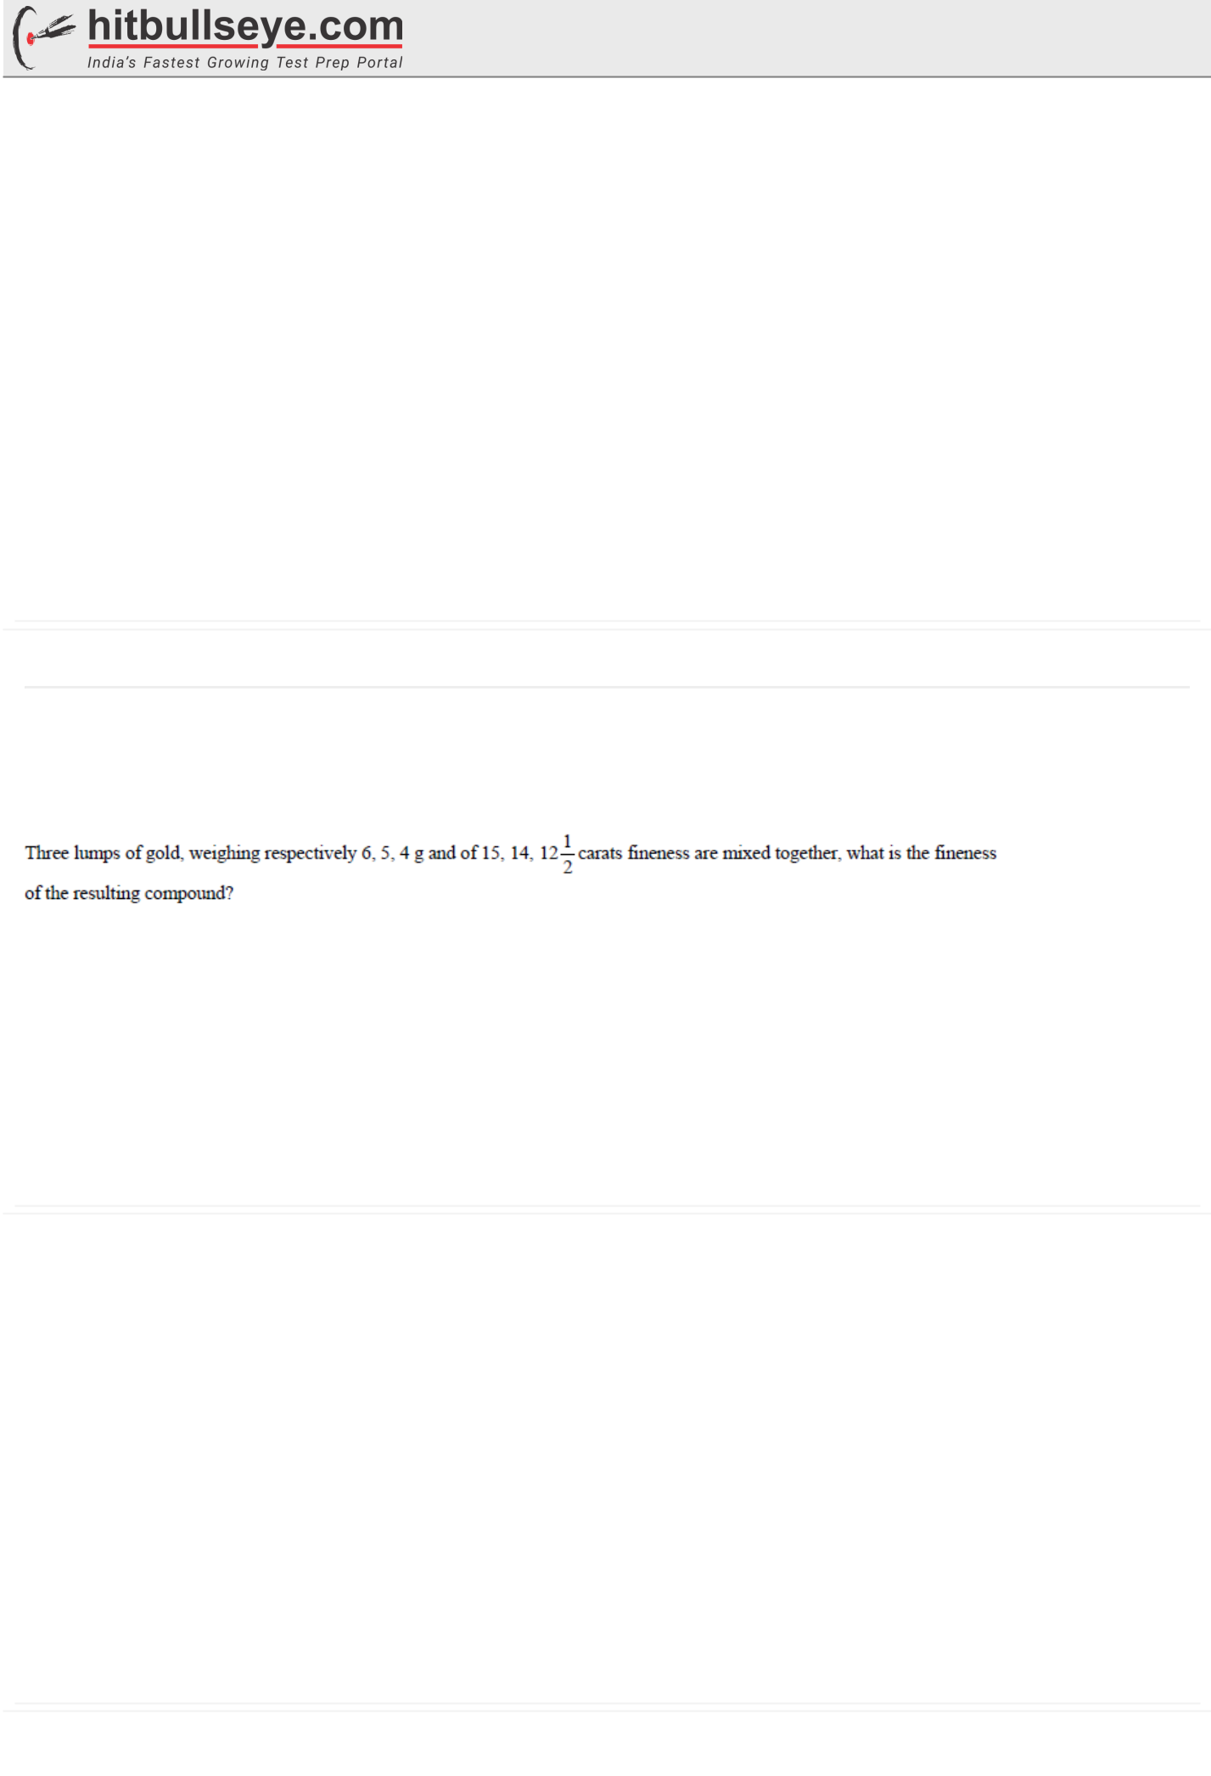
LPU CA 02 - 04 (A)

DIRECTIONS for the question: Solve the following question and mark the best possible option.

Question No. : 23

A vessel contains a mixture of milk and water in the respective ratio of 14:3. 25.5 litres of the mixture is taken out from the vessel and 2.5 litres of pure water and 5 litres of pure milk is added to the mixture. If the resultant mixture contains 20% water, what was the initial quantity of mixture in the vessel before the replacement? (inlitres)

A) 51 B) 102 C) 68 D) 85

DIRECTIONS for the question: Solve the following question and mark the best possible option.

Question No. : 24

The concentration of petrol in three different mixtures (of petrol and kerosene) is 1/2, 3/5 and 4/5, respectively. If 2 litres, 3 litres and 1 litre are taken from these three different vessels and mixed together, what is the ratio of petrol and kerosene in the new mixture?

A) 4:5 B) 3:2 C) 3:5 D) 2:3

Section : Section 5

DIRECTIONS for the question: Solve the following question and mark the best possible option.

Question No. : 25

A) 14 carats B) 16 carats C) 12 carats D) 18 carats

DIRECTIONS for the question: Solve the following question and mark the best possible option.

Question No. : 26

A container contains 40 litre of milk. From this container 4 litre of milk was taken out and replaced by water. This process was repeated further two times. How much milk is now contained in the container?

A) 16.9 litres B) 29.16 litres C) 32.4 litres D) 36 litres

DIRECTIONS for the question: Solve the following question and mark the best possible option.

Question No. : 27

A vessel contains 3 litres of glycerine.1 litre of glycerine is taken out and 1 litre of water is added. Then 1 litre of this mixture is taken out and 1 litre of water is added. What is the ratio of water to glycerine in the final mixture?

A) 5:9 B) 5:4 C) 2:3 D) 4:9

DIRECTIONS for the question: Solve the following question and mark the best possible option.

Question No. : 28

From a cask of wine, containing 64 litres, 8 litres are drawn out and the cask is filled up with water. If the same process is repeated a second, then a third time, what will be the proportion of wine to water in the resulting mixture?

A) 343:169 B) 343:512 C) 169:343 D) 512:343

LPU CA 02 - 04 (A)

DIRECTIONS for the question: Solve the following question and mark the best possible option.

Question No. : 29

Deepak has one litre milk with him. In the first hour, he drank 4% of the milk and replaced it with equal amount of water. In second hour, he drank 8% of the mixture and replaced it with equal amount of water. He continued it every hour i.e. in the 24th
hour he drank 96% of the mixture and replaced it with water and in 25th hour, he drank the entire mixture. Find the ratio of the total amount of milk and water that he drank during 25 hours.

A) 4: 13 B) 2: 23 C) 1: 12 D) 3: 11

DIRECTIONS for the question: Solve the following question and mark the best possible option.

Question No. : 30

A bottle contains 50 liters of milk. From this bottle 5 liters of milk was taken out and replaced the water. This process was repeated further for three times. How much milk is now contained in the bottle?

A) 32.8 liters B) 34.4 liters C) 36.8 liters D) 46.5 liters

